What will happen when I am referred to the group?  We will meet with you and talk about how your difficulties have developed and what keeps them going.  We will then write you a letter of our understanding of the current difficulties from your story and how the group may be helpful.  If we decide to go ahead with the group, initial sessions will explain more about what MBT is and what to look out for in your daily life. | The group  The Mentalising for Men Group takes place weekly.  When? Wednesdays between 5.30 and 6.45pm  Where?  4th Floor,  Barts House,  Black Lion Street,  Brighton BN1 1JE  Who will run it?  There are 3 of us running the Mentalising for Men Group.  We are a Psychologist, Psychiatrist and Occupational Therapist.  We all work for Sussex Partnership NHS Trust and are trained in MBT.  In addition, we have 2 men with lived experience supporting new group members to join  Referral is through your GP |   - MFM  - Mentalising for Men  - Group  
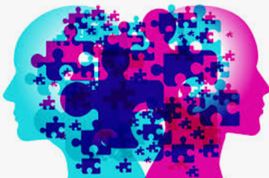  Mentalising for Men  We are running a group locally in Brighton for men who struggle to manage their emotions and their relationships.  They may have had difficulties in their past which have become more complex as they have become older.  This group uses a therapy called mentalisation based therapy (MBT) to help people make sense of interactions, interpersonal conflicts, and people's states of mind.  The group aims to help members develop new ways of relating to others and hopefully feel better about themselves.  MBT has a primary focus on the here-and-now. Your past experiences may come up in treatment but the focus is on recent events and difficulties in mentalising. | Do you struggle with any of the following?  - Feel your mood is low but not sure what to do about it?  - Put yourself in dangerous or risky situations, often without thinking about the consequences for yourself or other people?  - Sometimes get involved in illegal activity (you may have a criminal record)?  - Behave in ways that are unpleasant for others?  - Have sides of you that you don't feel happy with?  - Feel very easily bored and act on impulse – for example, you may find it difficult to hold down a job for long?  - Behave aggressively and get into fights easily?  - Do things even though they may hurt people and regret it afterwards?  - Often find emotions difficult, or you just feel numb a lot of the time?  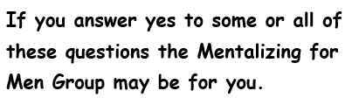  - Have used drugs or alcohol to help manage difficult situations? | What is Mentalisation- Based Therapy(MBT)?  MBT is an evidence-based psychotherapy.  It helps to make sense of our own and other people's thoughts, beliefs, wishes, and feelings and to link these to our and other's actions and behaviours.  It is an important skill to help us navigate all relationships. However, some people find it more difficult to mentalise in certain situations than others. MBT is particularly useful for people who live with long-term difficulties in relationships. They can experience distress which may result in destructive behaviours such as aggression towards others.  It is also helpful for people who may be distrustful of other people and have difficulty in reading other people’s responses to them.  MBT aims to improve a person’s capacity to mentalise. It focuses on what is going on in their mind and in the minds of other people and link this to understand and alleviate problematic behaviours.

