|  |  |
| --- | --- |
| Total Count | 82 |
| Very Good | 72 |
| Good | 2 |
| Neither Good nor Poor | 5 |
| Poor | 2 |
| Very Poor | 1 |

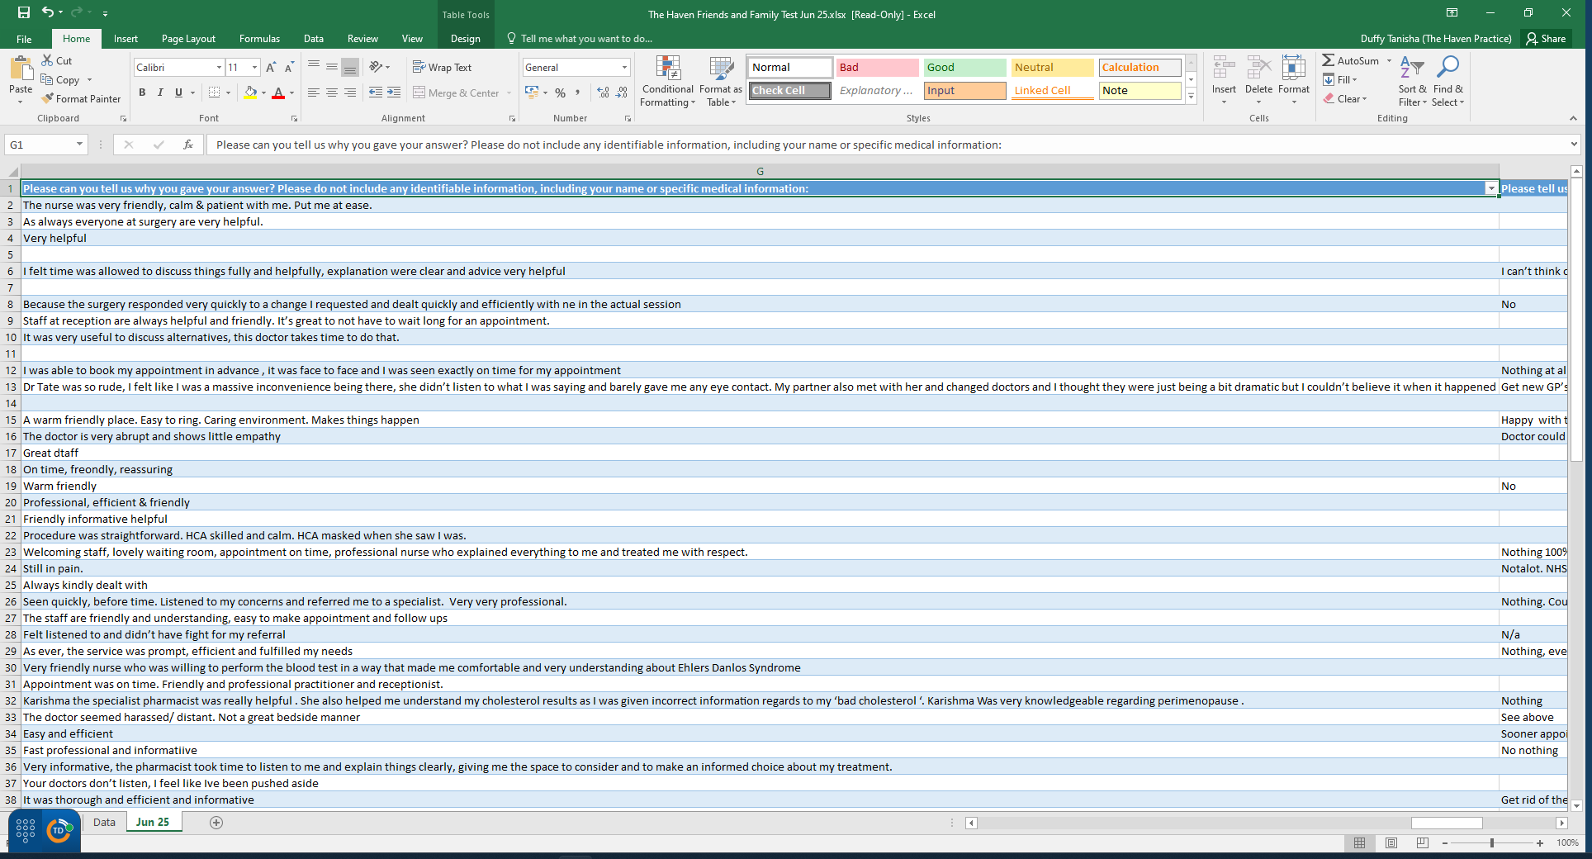**FFT – June 2025 Results**

